Penshurst CE Primary School
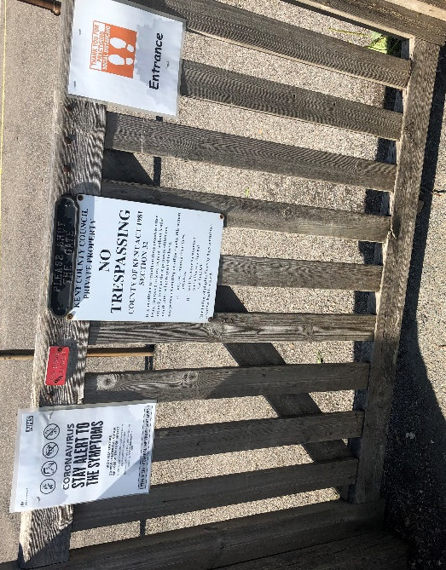
September 2020

Please enter via the single gate:
A member of staff will be present on the playground to show your child/children into school.

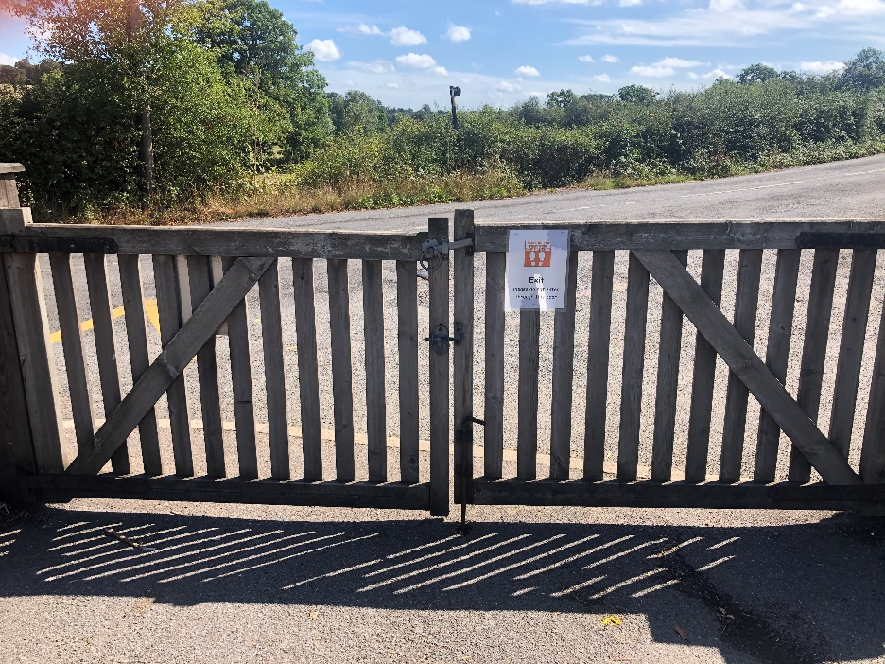

After dropping off your child please exit via the double gates

Please be mindful of other pedestrians.
Please enter the playground and do not wait on the pavement.

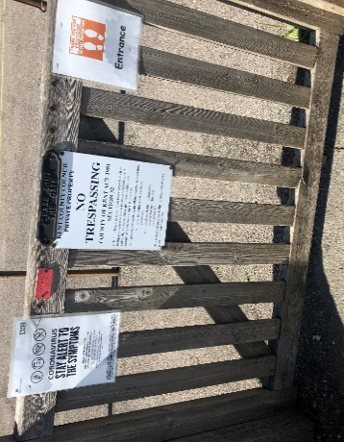
‘Pick-Up’

Enter the playground through the single gate. Do not wait on the pavement.

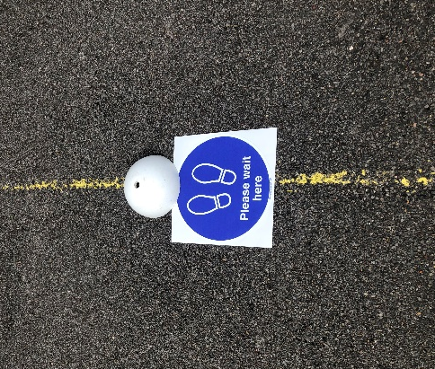
Wait at a cone (please wait here sign).

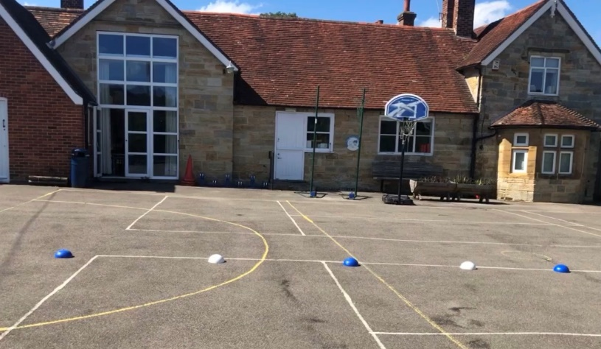

These are placed to allow for parents to be distanced in a similar way as when queuing to enter a shop.
A member of staff will bring your child/children out onto the playground.

Please exit via the double gates – please remember to be mindful of other pedestrians.

