PENSHURST CE PRIMARY SCHOOL

Fascinating Fact Finding Challenge

A few teasers to start this week…let’s give your brilliant brains some exercise.
What happens twice in a week and once in a year , but never in a day?
What is put on a table and cut, but never eaten?
What question can you ask all day long and get a different, correct answer each time?
- Can you put the following in order? : quatre, dix, zero, trois, huit un, cinq, sept, neuf, deux, six?
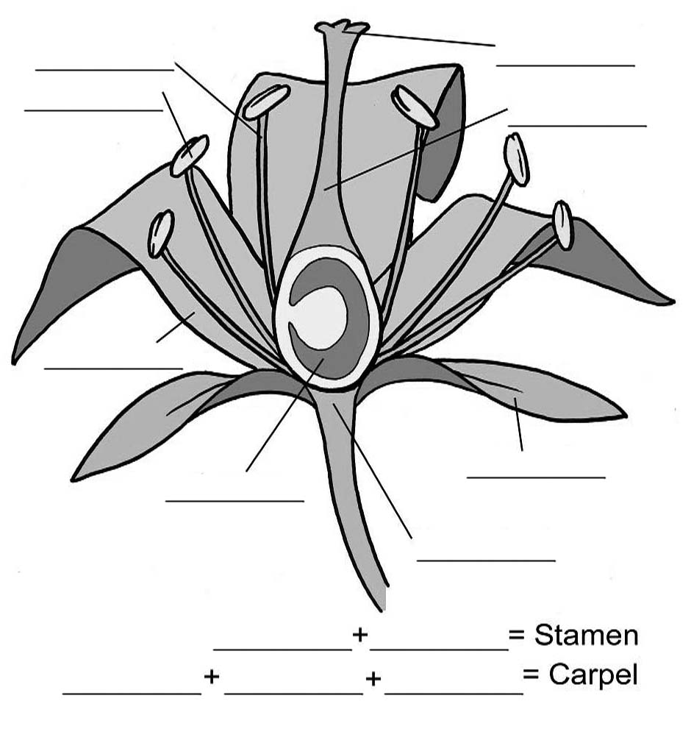
- Flower structure diagram: can you identify the structure and name different parts of a typical flower?
3.
Mountains make up about one-fifth of the world’s landscape. Heights of mountains are generally given as height above sea level.
The world’s highest peak on land is …………. ……………
It is ……………..m high
The highest mountain in Great Britain is …………………….

4a)
Georges Seurat was part of a famous art movement who painted using thousands of tiny dots of colour. What was it called?
Spotillism
Pointillism
Dotillism
Dabillism

b)
Art which is simplified by reducing the number of colours, lines, textures, and shapes is known as what?
Bareness
Minimalism
Simplicity
Borin
c)
In the 1920s, a group of artists painted strange scenes including melting clocks and elephants on stilts. They were called what?
Surrealists
Unusualists
Strangeists
Bizzareists

5. Spell the missing word

We had a ———— at our party.

This large mammal is an ——————. .

Number _____ is before number 10.

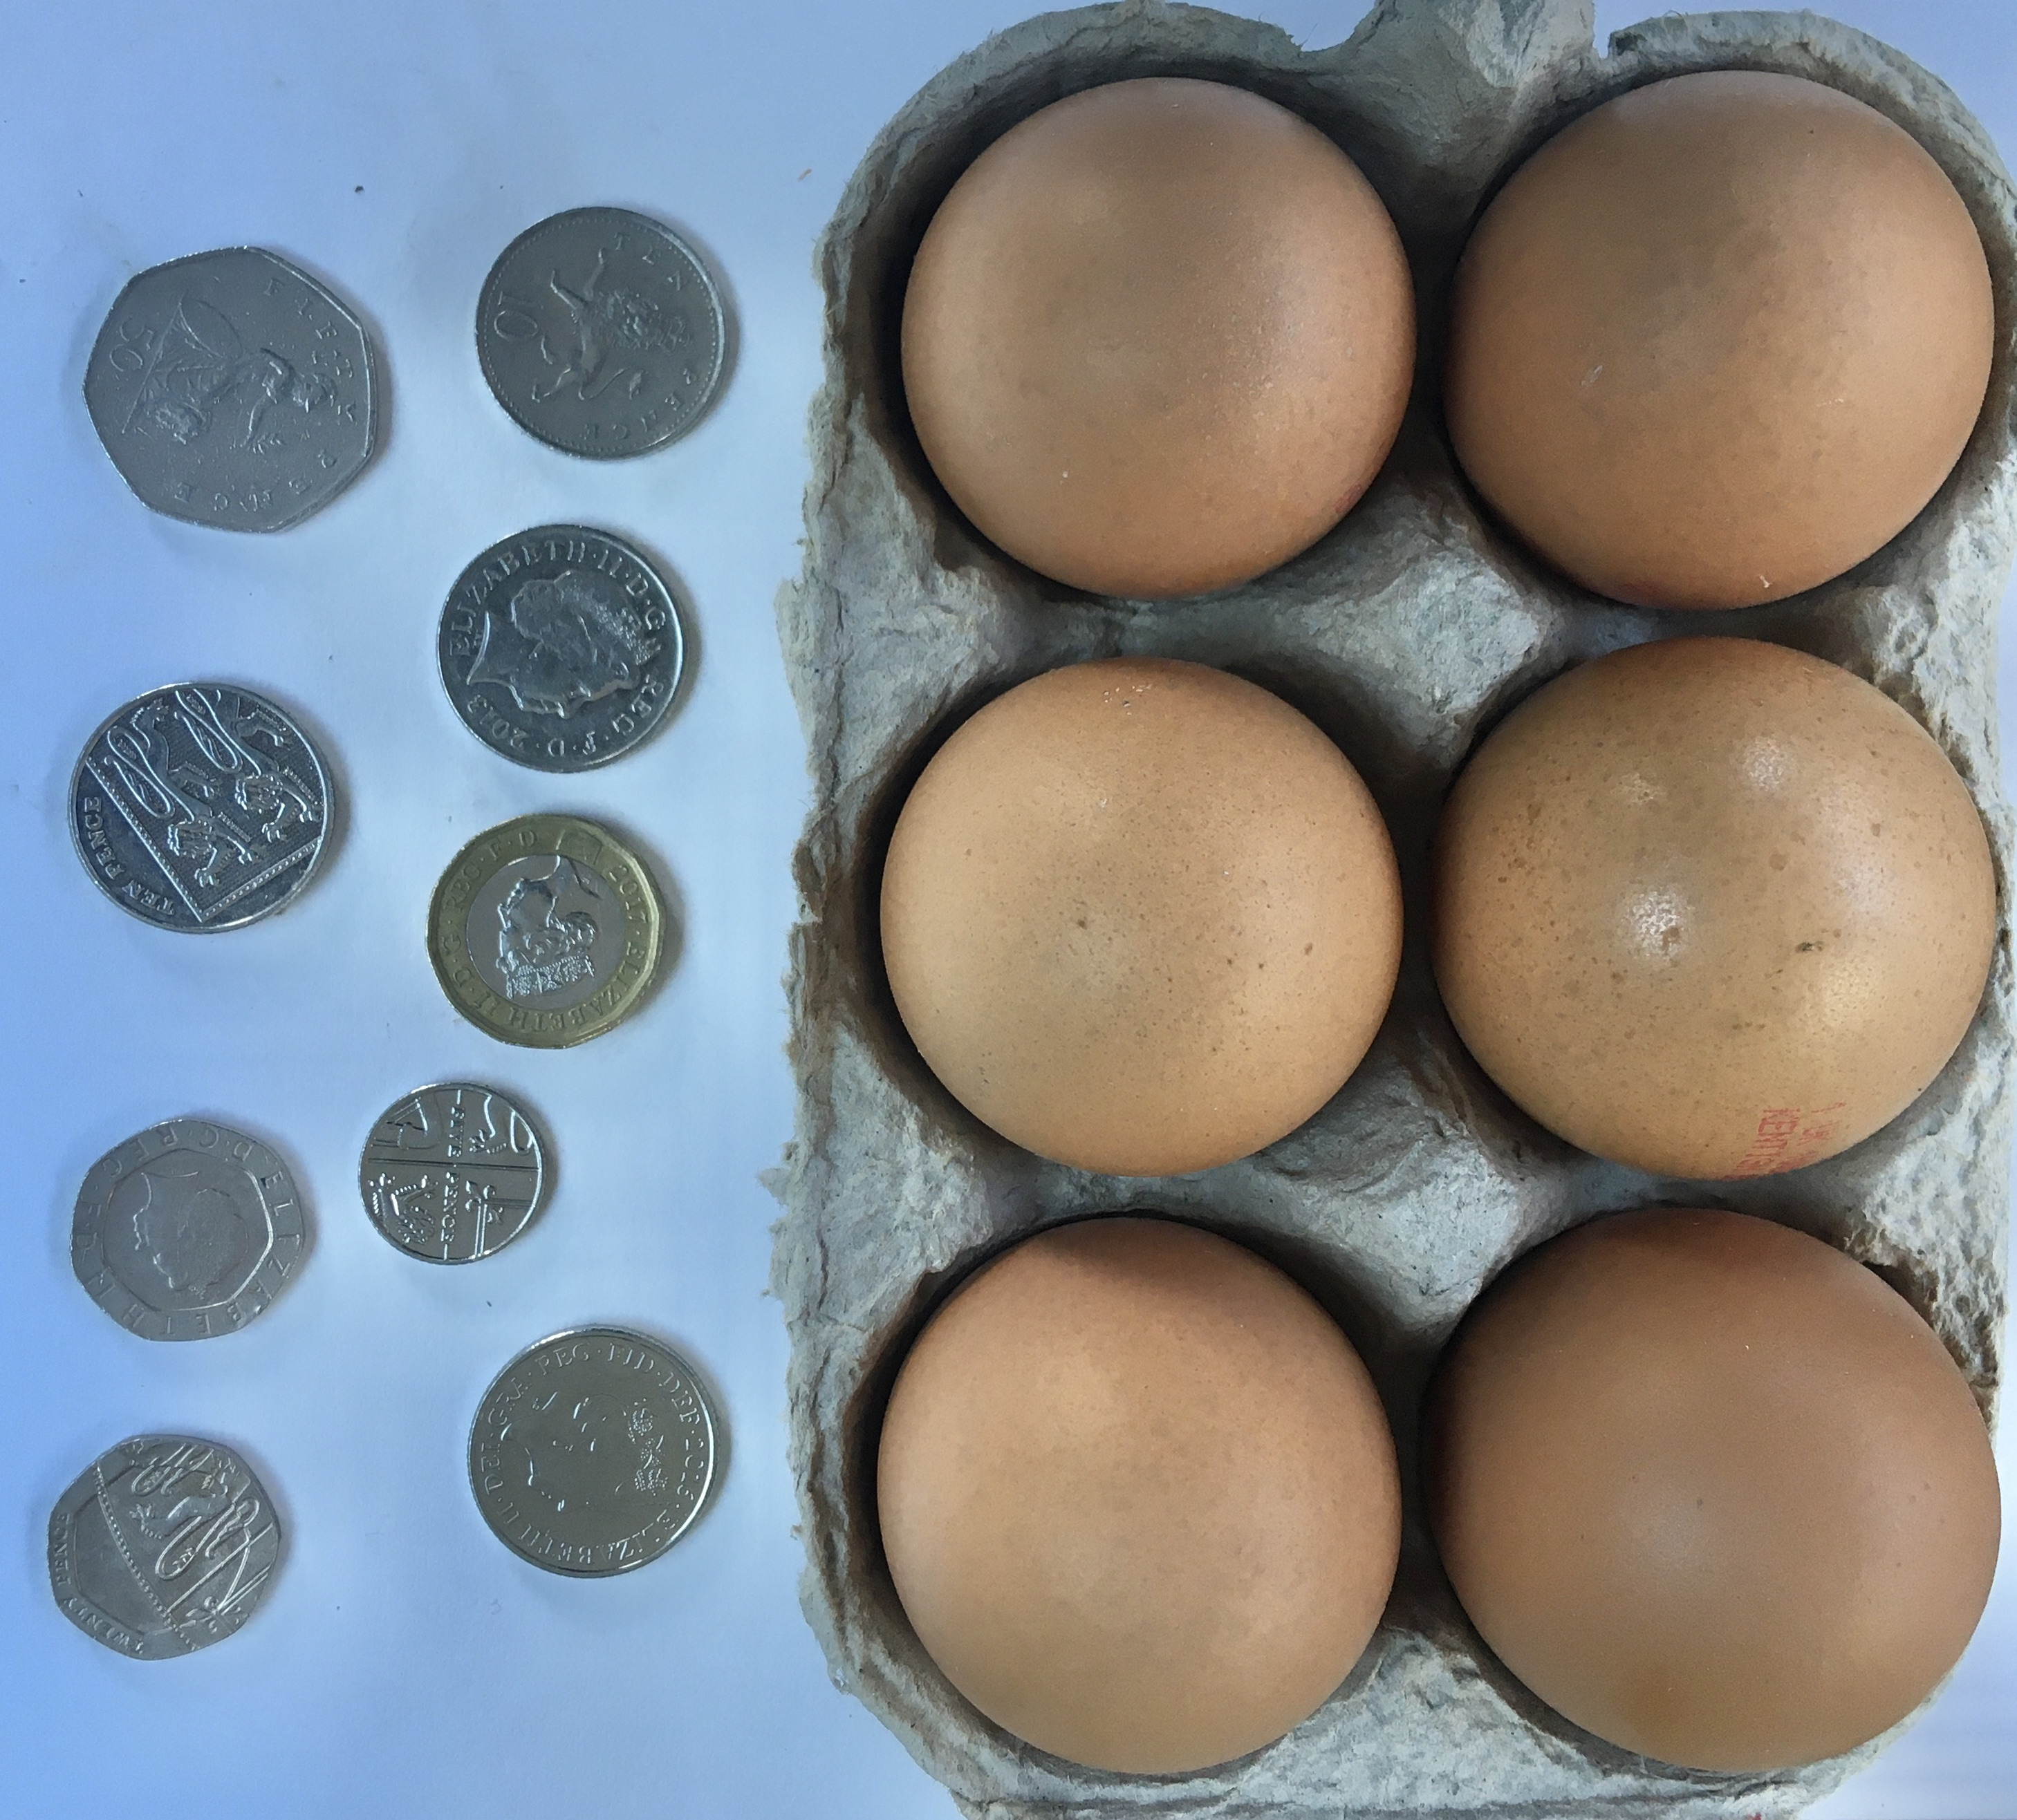
6. (a) These eggs cost 30p each, how much did the box of 6 eggs cost?
b) How much change is left from £1 would I get?

7. Count the fruit and vegetables below to help you solve the next challenge.

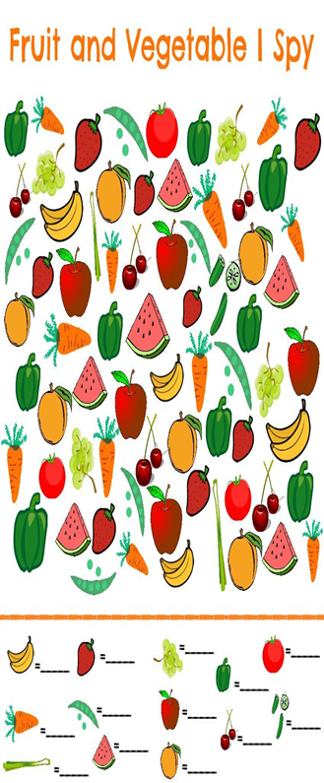

8. Green peppers + carrots x apples - oranges =

9.Which compass point is between North and West?
East
South
North West
West North
10.
a) What do Christians celebrate at Easter?
Jesus' death
Jesus' birth
Jesus’ resurrection
Jesus' baptism
b)Hindus believe that people's actions decide what form their next incarnation will take. What is the term for this?
Karma
Nirvana
Krishna
Vedas
c)The name Islam comes from the word 'Salaam', which means .......
love
freedom
peace
justice
—————————————————————————————————————
Well done for completing the challenge.You have given your marvellous brains a work out. Did you know that brain scientists believe that if you concentrate and repeat a fact 5 times to yourself, you will remember that fact for ever!!!
Useful to know if you want to a chance to win the INTER HOUSE school quiz which we will be running when we all return to school. In the mean time you can gain HOUSE POINTS by submitting your answers to the quiz by email. Please include your :
NAME
CLASS
HOUSE, if you know it.

Each entry will gain 2 house points to be added to the house tally.
All completed and correct submissions will gain 5 house points!!
Either type answers or send a picture file. ………..GOOD LUCK

There is a BONUS question this week worth 5 house points:
Who has two birthdays, did not go to school, served in World War II and will be 94 years old on April 21st 2020?

COOKERY CHALLENGE

Would you like to become a top Baker?
Do you like playing with dough?
If so this cooking task may appeal to you….

Use your imagination and create your own yummy scrumptious, mouth watering ……. SODA BREAD

Makes about 16 small scones or 8 chunky ones.

450g plain white or whole wheat flour.
1 level teaspoon salt ( savoury only ) or
1level teaspoon bicarbonate of soda
1 to 2 teaspoons of your chosen savoury ingredients or
100g of sweet ingredient and 1 tablespoon of caster sugar
400ml of butter milk or sour milk ( to sour milk, add 3 generous tablespoons of natural yogurt or juice from 1/2 Lemon to 400ml fresh milk.

You can be creative with your ingredients ….which could include: Savoury additions like cheese, rosemary, thyme, sage , parsley , chives nuts and seeds . OR sweet additions dried fruit, chocolate chips, cinnamon and all spice for example. But not all at once…YUCK !!

Method.
- Preheat the oven to 250C (475 F), Gas mark 9
- Sieve the dry ingredients into a bowl, then mix in your chosen ingredients.
- Make a well in the centre. Pour in all the milk at once. Using one hand, with your fingers outstretched like a claw( or a pallet knife), stir in full circular movement from the centre to the outside of the bowl. The dough should be soft , though not too wet and sticky.
- When the dough comes together, turn it out on to well floured surface. Pat the dough until it is about 2cm thick. Cut into round or square shapes. A simple way to do it is to make a circle and cut it in 1/2 , the 1/4 then 1/8th.

- Place try in hot oven and cook for 10- 15 mins (depending on the size) until golden and sounding hollow when tapped on the bottom.
- Wait for them to cool and then ENJOY.

