SUMMER SUN AND SHADE – Year 2/3
Week 4  Science  Watch Clip 1 which explains how shadows are formed. Go on a shadow hunt in your house or garden and each time you find one, work out the light source and the object that is blocking the light to make the shadow. Produce a poster, drawing some of the objects and their shadows to show your understanding.  English  Write a story about the day you notice your shadow is acting differently from you and the adventures on which it takes you!  Art/DT  Strike a pose and ask a family member to draw around your shadow using chalk. Colour in your shadow in an interesting way. Make a family group!  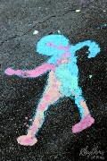 | Week 5  Science  Watch Clip 2 and then design your own puppet show. Think of ways to make your puppet grow smaller and larger. Think about how the distance between the puppet and the light source affects the size of the shadow created.  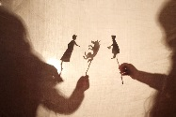  English  Write a story or a play script to accompany your shadow puppet show. Film your performance if you can.  Art/DT  Make a silhouette picture. On a sheet of white paper draw a scene and colour each object in black. As an alternative you could cut your objects from black paper and stick them on to the white.  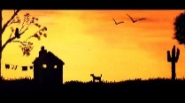 | Week 6  Science  Use your understanding of shadows to make a sundial. Push a long stick in to ground outside and observe how the shadow moves as the time of day changes. Watch where the shadow falls each hour of the day and place the correct clock face number in that place.  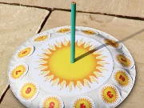  English  Produce a fact file about the sun and why it is a light source for the Earth. Find out why the sun appears to move across the sky during the day. Include pictures and diagrams to illustrate your writing.  Art/DT  Using junk materials, make a 3D model of the sun and earth to explain how light travels to the earth and why it is daytime in some parts of the word and the same time it is night in others. | Week 7  Science  Watch Clip 3. Show your understanding of light and light sources by drawing a picture of a room in your house labelling all of the light sources. Make sure you understand the meaning of the words opaque, translucent and transparent and label some objects in the picture of your room that match those meanings!  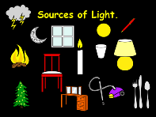  English  In a format of your choice, produce a document / poster / booklet which summarises your learning about light and shadow. Include questions for future research.  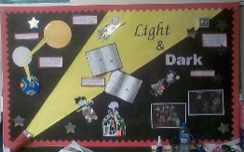
Clip 1 - https://www.bbc.co.uk/bitesize/clips/z8vfb9q
Clip 2 - https://www.bbc.co.uk/bitesize/clips/zkqw2hv
Clip 3 - https://www.bbc.co.uk/bitesize/clips/zg6r82p
Daily Skills And Drills

