BLUE ABYSS – Year 4
Week 4  Art/DT  Create “Top Trumps” style fact cards about creatures of the sea.  Science  Watch clips online from the BBC’s Blue Planet series about creatures of the deep. Make notes on how creatures have adapted for survival in this extreme environment. Select an adaptation from your observations and find out more about it. Present your information in a way of your choice.  English  Find as many amazing facts about sharks as you can and present them in an interesting and exciting way.  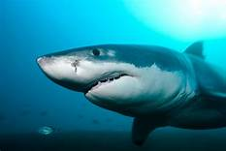 | Week 5  Art/DT  Design an exciting “Under the Sea” board game. Think about the end point of the game and challenges along the way.  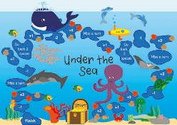  Science  Find out the meaning of “bioluminescence’. Watch film clips of bioluminescence in action. Choose a creature that shows this property and write a short biography about it – how it looks, how it behaves, what it eats, where it lives and its special feature.  https://youtu.be/kdufLq2P1Ag  English  Make a tourist leaflet for people visiting Australia’s Great Barrier Reef. Persuade people that the Reef is a great destination to visit but highlight some of the current conservation issues. | Week 6  Art/DT  Look at images and videos that show an array of tropical fish and corals. Draw an imaginary seascape using what you have seen for inspiration.  https://youtu.be/cC9r0jHF-Fw  Science  Create a new and original “monster of the deep” using what you have learned about deep sea adaptations. Consider the type of creature it might be (fish, mammal, cnidarian, mollusc or chinoderm), its size, features, prey and how it protects itself.  English  Find out about a famous undersea explorer such as Robert Ballard, Sylvia Earle, William Beebe or James Cameron. Make an information leaflet about them to present their achievements. | Week 7  Art/DT  Draw the view of the ocean you might see if looking through the window of a submarine.  History  Find out why the 1872 Royal Navy ship, HMS Challenger is considered so important and how its story has contributed to modern oceanography. Create a short documentary presentation.  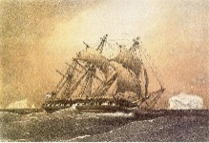  English  Demonstrate your learning about the oceans by writing a “True or False?” quiz with fascinating facts about creatures and other aspects of the seas.
Daily Skills And Drills
