revolution – Year 5/6
Week 4  Art/DT  Look at the painting “The First Council of Queen Victoria”. Summarise what you think the picture shows and what it tells us about politics and power at the start of Victoria’s reign. Draw your own version of the painting.  http://www.gogmsite.net/_Media/1837-queen-victoria-presidi_med.jpeg  Geography  Research the Victorian Empire and create annotated maps showing the extent of British rule. Choose a single area to focus on, such as Britain in India and write about this.  History  Look at various images of Victorian inventions. Check the invention dates and order them on a timeline with notes about why they were important. Find out who invented them and write a short biography about each inventor. | Week 5  Art/DT  Use a range of recycled materials to make a model Victorian town. Plan the layout by making detailed drawings. Paint the model buildings to make them look authentic.  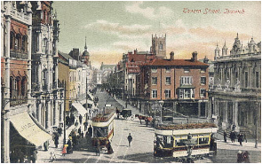  History  Find out about The Great Exhibition in 1851. Design a persuasive poster to advertise the exhibition and explain to people what they might expect to see there and why they should visit.  English  Listen to the story of the Victorian chimney sweep. Imagine you have been forced to do this job through poverty and write a story or diary about your experiences. https://www.bbc.co.uk/teach/school-radio/history-victorians/zh2w47h | Week 6  Art/DT  Look at a range of art work from Victorian artists such as John Everett Millais, Edward Robert Hughes, John William Waterhouse and Dante Gabriel Rossetti. Choose a favourite and sketch out and paint a composition in their style.  . History  Find out about life in the Victorian slums. Find out what they were, how they arose and what everyday life was like for people who lived there  English  Imagine you have spent the day visiting The Great Exhibition. Write a diary entry describing the signs, sounds, smells and atmosphere of the day and describing some of the exhibits you have seen.  https://www.bl.uk/victorian-britain/articles/the-great-exhibition  .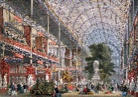 | Week 7  History  Find out about crime and punishment in Victorian England. Discover what types of crimes were common and which were considered the most serious. Consider why crime was rife during the Victorian era and how this was linked to poverty.  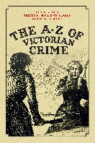  Reading  Listen to some poems by the Victorian poet, Edward Lear. Learn one by heart and record your performance.  https://youtu.be/oF7JoW23l4s  English  In the format of your choice, produce a document / poster / booklet which summarises your learning about the Victorian era. Include key questions for future research.
Daily Skills And Drills

(Year 6) 