A WALK IN THE FOREST – Year R/1
Week 4  Art/DT  Draw or paint a picture of a woodland creature using a range of images to carefully observe its features  Make a 3D junk model of your creature.  English  Using drawings and writing, make a book about your favourite woodland creature.  Science  In your own garden and when you are out for a walk with your family, collect different types of leaves. Use each leaf to work out the name of the tree and make a poster of them. Challenge yourself to find out the meaning of deciduous and evergreen and decide to which tree type each leaf you have collected belongs. | Week 5  Art/DT  Collect some sticks of difference sizes and use them as brushes to paint a woodland picture. Add leaves, moss and other items you’ve collected to your picture for texture. Take rubbings of tree bark and other natural materials and add these to your picture.  English  Imagine you have found a pathway and are about to follow it into the woods. You meet an animal or a magical creature. Write a story about your adventures.  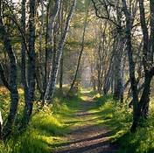 | Week 6  Art/DT  Make a home for a tiny, magical creature such as a woodland imp. Use a variety of small items such as moss, sticks, pebbles, leaves and other materials to create it. Consider how your creature would get in and out of their home and what they might need to make their stay comfortable!  Use mud or clay to make a tree boggart. Press mud or clay onto a tree trunk and sculpt a face into it using sticks, twigs, leaves stones and bark.  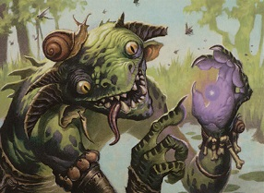  English  Listen to the story of Hansel and Gretel. Write the story or part of the story in your own words.  https://youtu.be/QBHCVfI5w7E | Week 7  Art/DT  Create miniature treats for a tiny tea party. Make some small sandwiches, cakes and other treats.  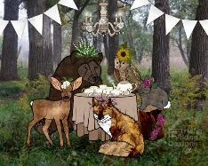  Geography  Build a mini woodland in sand and mud trays creating trees from twigs, sticks, pine cones, leaves and other natural materials. Add extra details such as paths, clearings, grassy patches, gates, fences and dens. Draw a map of your woodland to guide “visitors” around it.  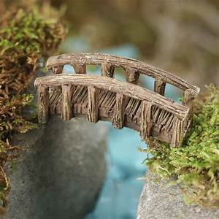
Daily Skills And Drills

